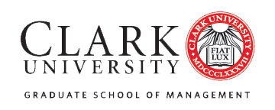

FIN 5404 Investment Fund

Student Manager Application

The course is designed to introduce students to investment research and portfolio management strategies. As a student manager, you will take on the fiduciary responsibility of managing Clark University’s endowment – this requires extensive independent research, daily oversight of your investment ideas, and ongoing monitoring of our portfolio.

Requirements for being accepted as a student manager:

- Only open to MSF students and MBA students with a concentration in Finance.
- Minimum of 3.3 (B+ average) cumulative GPA.
- Completed application.

Applications should be submitted to Professor Steve Ng, CFA (sng@clarku.edu) and
cc Academic Advisor Yue Gao (MSFAdvisor@clarku.edu).
The deadline to apply is 5pm Eastern Standard Time on Thursday, August 4th.
Late applications WILL NOT be considered.

Personal Information
Name:
Student ID Number:
Email Address:
Telephone Number:
Semester You Will Complete Your Degree (Semester/Year):
Clark GSOM Cumulative GPA:

Investment Process
- What makes a good investor?
- Why are you interested in investment management?
- Can you conduct independent research with minimal guidance?
- Do you work well in a group?
- Can you handle a demanding work load throughout the semester?

DO NOT APPLY if you do not have the time to fulfill your FIDUCIARY RESPONSIBILITY in managing our portfolio.

Please note: Students accepted will be expected to complete the Bloomberg Essentials training using the Bloomberg software prior to the start of the course, so you must be willing to commit several hours to do so over the summer break.

